

MySQL Assignment

SQL Tasks

Jonah Gray

GMCA 5

**Initial Task** - Create a query with a new column called points + 10

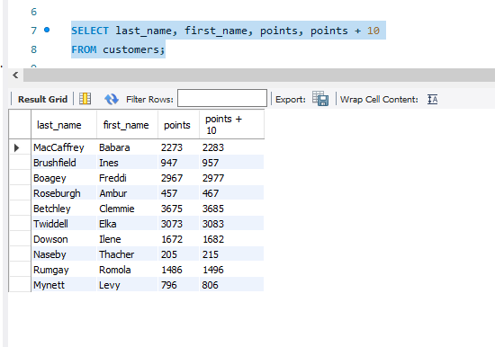

**Task 1** - Create a query to add 10 to the points column, multiply it by 100 and add a new column with a new header ‘discount factor’. This is achieved using the AS command to rename a column.

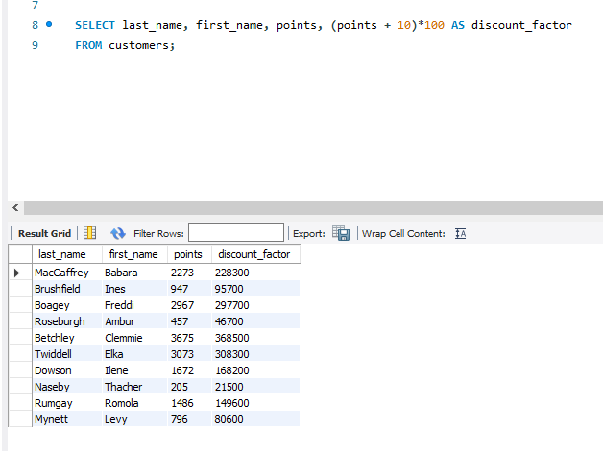

**Task 2** - Create a query including a new column where unit_price is increased by 10% and rename it ‘new price’. This is done by using the AS command to rename a column.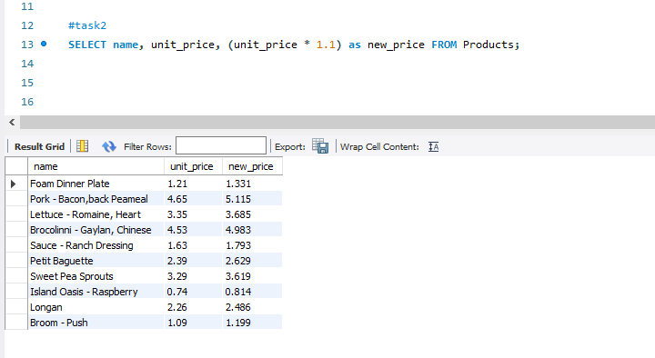

**Task 3** - Create a query to find all the customers whos were born after ‘1990-01-01’. This is done by using the WHERE command to filter the column birth_date.

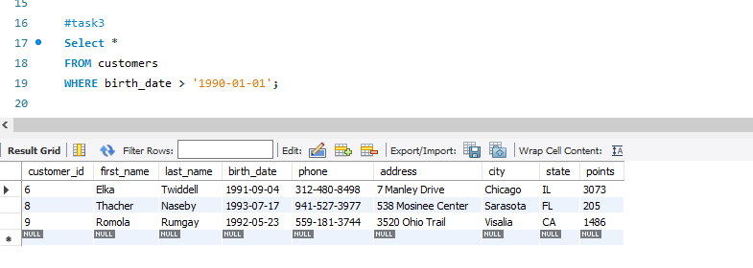

**Task 4** - Create a query to find out the name of the product with the highest stock. This is done by using the order by command to filter the quantity in stock by highest to lowest, and using the limit command to only return the first value.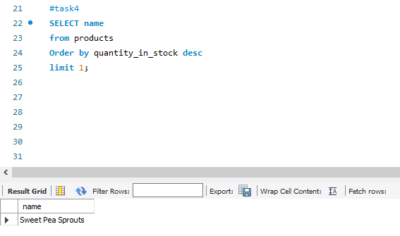

**Task 5** - Create a query to find the most expensive product. This is done by using the order by command to filter the quantity in stock by highest to lowest, and using the limit command to only return the first value.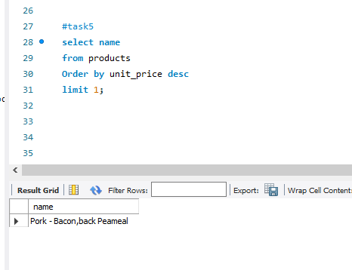

**Task 6** - Create a query to find out the first name, last name, address and birthdate of the oldest customer. This is done by using the order by command to filter the quantity in stock by highest to lowest, and using the limit command to only return the first value.

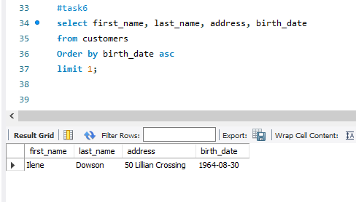

**Task 7** - Create an EER Diagram. This diagram shows all the relationships between all of the tables within the database.  
